SMART FARMER – IoT ENABLED SMART FARMER APPLICATION CREATING AN ACCOUNT IN FAST2SMS DASHBOARD

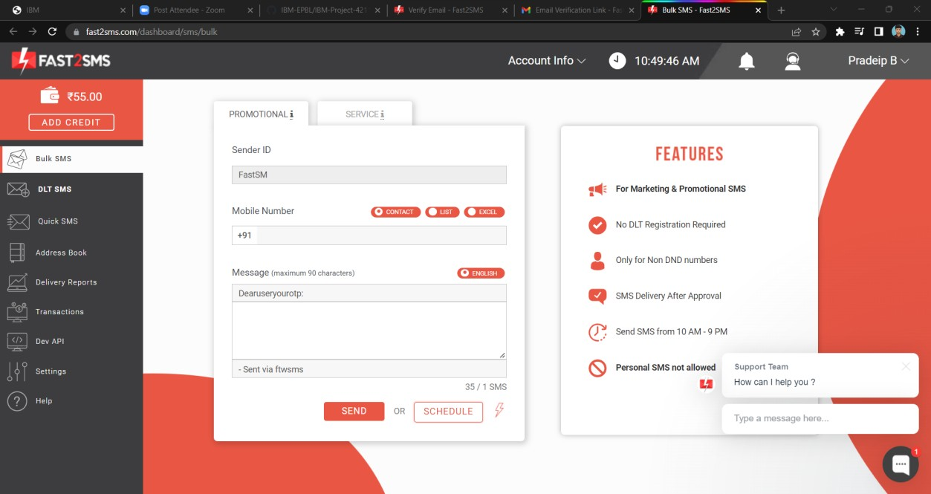

SUBMITTED BY :THENNARASU

ROLL NO : 718020L420